# **Introduction to Experience**

**Zoom Electric** (ZE) is an electric automotive venture of a leading automotive manufacturer **ZOOM MOTORS India Private Limited.**

You are working as an analyst in the sales & operation team at **Zoom Electric**. The team is responsible for executing the pre-orders, sales client visits, website sales, and analyse the visit session created on the website and analyse the sales funnel.

Zoom Electric has automotive and scooters as its product line - FioNex, Sprint, and Parker and its Limited Editions are some of its premium scooter variants.

ZE has introduced a new scooter variant, Sprint in the 2-wheeler EV scooter segment. Initially Sprint Scooters' sales numbers were quite impressive in the first two weeks of launch but suddenly it started decreasing unexpectedly.

As a data analyst, you have been assigned to validate the sales drop for Sprint scooters and figure out the reasons for this decline.

**Skills Used for Analysis**

|  |  |  |
| --- | --- | --- |
| **Skill Stack** | **Tools & Techniques** | **Skill Levels** |
| Tools | Excel | Basic |
| Python: Pandas, Matplotlib, Seaborn | Intermediate |
| Analytical Skills | Exploratory Data Analysis | Intermediate |
| Data Collection | Basic |
| Core Skills | Problem Solving | Intermediate |

# **Approach**

# Having understood the problem and the business process, this section outlines the high-level approach necessary for solving this experience. Entire Analysis is divided into three milestones to find the exact reasons for sales drop.

# **Milestones**

## **MS1: Quantifying the sales drop: Sprint Scooter sales in first 3 weeks.**

The growth in sales volume experienced a decrease two weeks following the launch of the **Sprint** scooter. Despite a promising start in the first two weeks, sales began to decline by 20 % thereafter.

Here in this Milestone, we are going to validate the sales drop for the **Sprint** scooters sales volume.

“*Validate that sales has declined*” means calculating sales growth % (*or more precisely sales volume growth %*) in a specific time period.

Note: Since Sales volume were encouraging in the first two weeks of launch you can take here 7 days’ time period for comparing current week sales to the previous week sales (*current period sales vs prior period sales volume*).

### 

### Expected Output:

created a ***sales volume and growth summary*** Table.

|  |  |  |  |  |
| --- | --- | --- | --- | --- |
| **sales_transaction_date** | **quantity_sold** | **current period sales**  (Cumulative _quantity-last 7 Days) | **Prior_period_sales**  (Cumulative _quantity_Last 7days -Prev Day) | **% growth**  (Week on week) |
|  |  |  |  |  |
|  |  |  |  |  |

* For validating the sales volume growth, created a summary table from the sales data set with the following.

1. No of units sold summarised over **sales volume** (In the **sales dates** in their ascending order)
2. **current period sales volume** & **prior period sales volume** and compare the % change under the heading **% sales volume growth.**

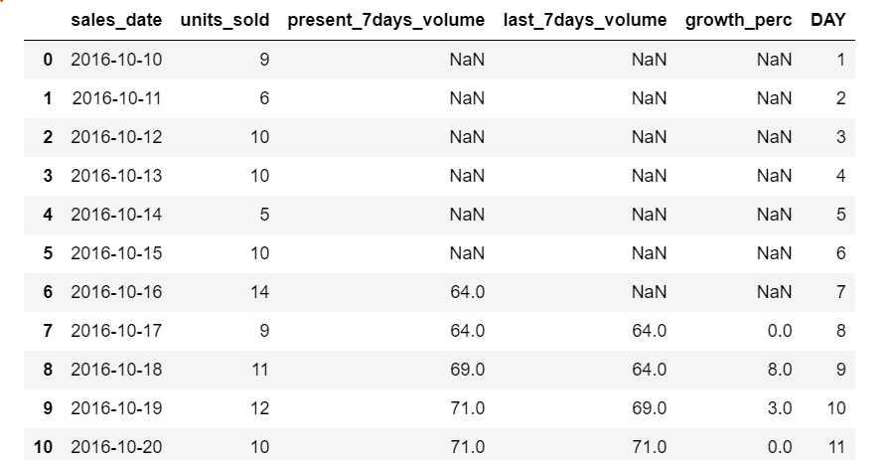

* Plotted the line chart growth % and present 7 days cumm sales against the sales date for initial 20-30 days and analysed the trend.

Code:

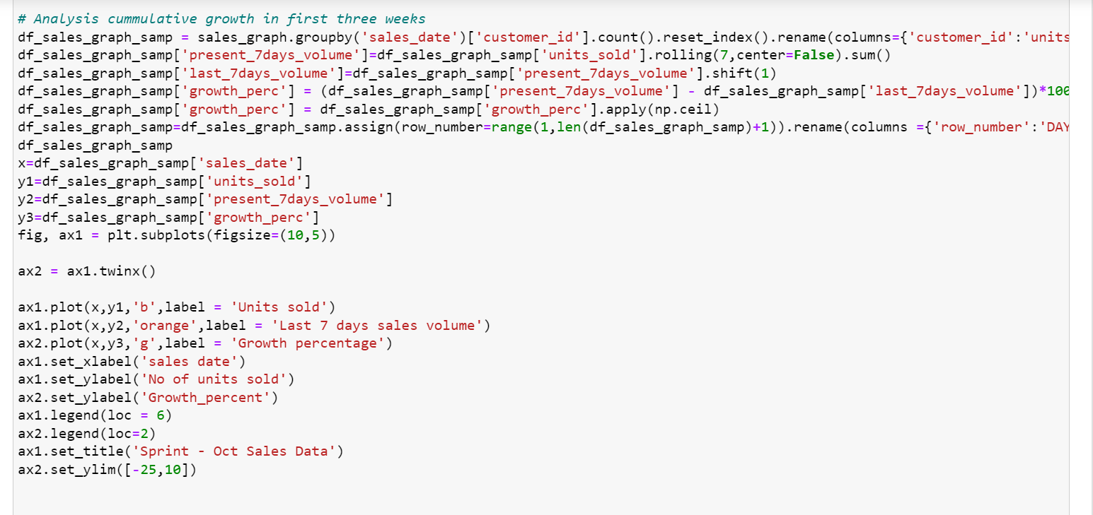

Output:

Conclusion: In the above plot, we can see the % growth volume decreased after 2 weeks.

## **MS2: Analysing reason for sales decline 1: launch date assumption.**

Zoom Electric used to launch its product usually in the first half of the year , Sprint is the only scooter which was launched in the second half of the year( in the month of October).

* By Comparing the growth % of Sprint with Sprint Limited Edition, FioNex 2013 or any other model that were launched on different production start- we have validated the assumption of – *Launch date impacted the sales growth.*

### 

### **Products Dataset:**

|  |  |  |  |  |  |  |
| --- | --- | --- | --- | --- | --- | --- |
| **product_id** | **model** | **year** | **product_type** | **base_price** | **production_start_date** | **production_end_date** |
| 1 | FioNex | 2010 | scooter | 63998 | 03-03-2010 00:00 | 08-06-2012 00:00 |
| 2 | FioNex Limited Edition | 2011 | scooter | 127998 | 03-01-2011 00:00 | 30-03-2011 00:00 |
| 3 | FioNex | 2013 | scooter | 79998 | 01-05-2013 00:00 | 28-12-2018 00:00 |
| 4 | DeltaPlus | 2014 | automobile | 920000 | 23-06-2014 00:00 | 28-12-2018 00:00 |
| 5 | Parker | 2014 | scooter | 111998 | 23-06-2014 00:00 | 27-01-2015 00:00 |
| 6 | Corpel | 2015 | automobile | 524000 | 15-04-2015 00:00 | 01-10-2018 00:00 |
| 7 | Sprint | 2016 | scooter | 95998 | 10-10-2016 00:00 |  |
| 8 | Sprint Limited Edition | 2017 | scooter | 111998 | 15-02-2017 00:00 |  |
| 9 | SigniaSafari | 2017 | automobile | 280000 | 15-02-2017 00:00 |  |
| 10 | Zelito800 | 2017 | automobile | 686000 | 15-02-2017 00:00 |  |
| 11 | DeltaPlus | 2019 | automobile | 760000 | 04-02-2019 00:00 |  |
| 12 | FioNex Zester | 2019 | scooter | 55998 | 04-02-2019 00:00 |  |

Here we are considering Sprint and Sprint LE for comparison because Sprint LE is launched only after 4 months of launch of Sprint. Let’s plot the % growth volume comparison for Sprint and Sprint LE.

Plot:

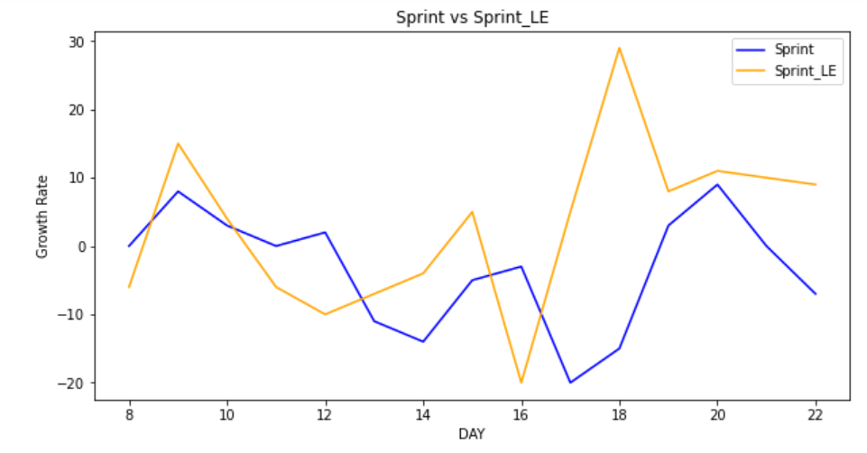

**Conclusion:** From the plot we can see that, Sprint LE sales growth is higher than Sprint Scooter sales even though Sprint LE price is higher than Sprint price. It concludes that launch date is one of the affecting factors for sales drop.

## **MS3: Analysing reason for sales decline 2: Email campaign.**

This milestone analyses email campaign and its impact on sales growth.

1. Collected entire details regarding emails of Sprint Scooter.
2. Data is collected only from 2 months before launch (digital marketing campaign started only 2 months before launch).
3. We are considering all emails for each customer, as one customer may receive multiple emails.
4. After receiving an email from ZE, customers has either opened it or not , then clicked the email or not.

We are calculating the email opening rate and Click rates, Typically the industry benchmark for a quality campaign is - **18%** email opening rate,**8%** click rate.

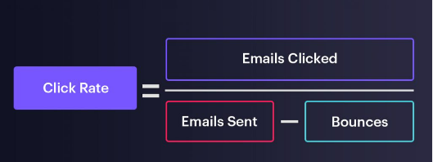

**Email Summary:**

Below is the email summary for Sprint email campaign. Contains both code and output.

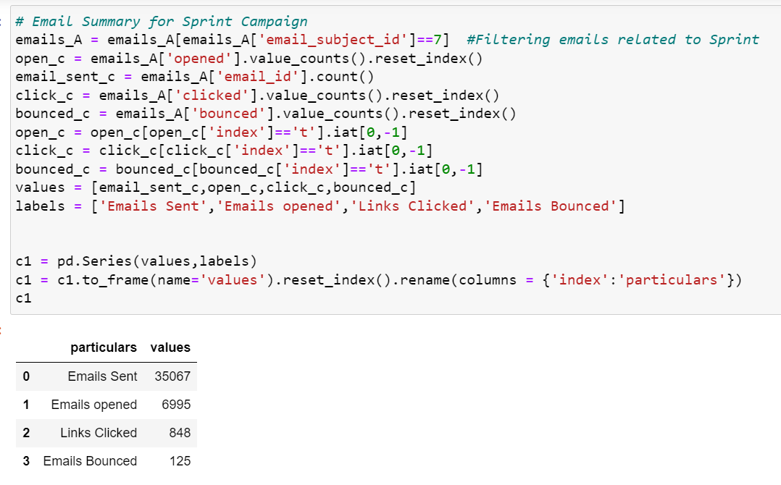

**KPI Summary:**

Below is the KPI details of email campaign. These KPI decides whether the campaign is impactful are not.

We have considered click rate and opened rate for KPI’s.

**Conclusion**: From above observation we can see that open rate crossed the benchmark value but click is very less than the Benchmark mark, so we can conclude that email campaign is not impactful.

**Overall Conclusion:**

* + - 1. Launch date affected the sales.
      2. Email campaign is not impactful.

**Attachments:**

Jupyter Notebook:  data sets: 